Project Planning Phase
Project Planning Template (Product Backlog, Sprint Planning, Stories, Story points)
Use the below template to create product backlog and sprint schedule
Sprint | Functional  Requirement  (Epic) | User Story  Number | User Story / Task | Story Points | Priority | User Type
Sprint-1 | Upload Housing Data | USN-1 | As a user, I can upload CSV files containing housing market data. | 2 | High | Customer
Sprint-2 | Fetch data from API | USN-2 | As a user, I can fetch housing data from external APIs. | 1 | Medium | Customer
Sprint-2 | Clean & Process Data | USN-3 | As a user, I can apply filters & transformation to clean raw data. | 2 | High | Customer
Sprint-2 | View Visualizations | USN-4 | As a user, I can view housing market trends through interactive graphs and charts. | 2 | Medium | Customer
Sprint | Functional  Requirement  (Epic) | User Story  Number | User Story / Task | Story Points | Priority | User Type
Sprint-3 | Save & Export Reports | USN-5 | As a user, I can download the generated reports in PDF/CSV format. | 1 | Low | Customer
Sprint-3 | Manage Users | USN-6 | As an admin, I can view and manage registered users. | 2 | High | Admin
Sprint-2 | Dashboard  Filtering | USN-7 | As a user, I can filter the dashboard results by city, price range, or year | 2 | High | Customer
Sprint-4 | View Usage Analytics | USN-8 | As a admin , I can view how many users are using each feature. | 2 | High | Admin
Project Tracker, Velocity & Burndown Chart: (4 Marks)
Sprint | Total Story Points | Duration | Sprint Start Date | Sprint End Date (Planned) | Story Points Completed (as on Planned End Date) | Sprint Release Date (Actual)
Sprint-1 | 20 | 6 Days | 24 Oct 2022 | 29 Oct 2022 | 1 | 29 Oct 2022
Sprint-2 | 20 | 6 Days | 31 Oct 2022 | 05 Nov 2022 | 7 | 05 Nov 2022
Sprint-3 | 20 | 6 Days | 07 Nov 2022 | 12 Nov 2022 | 3 | 12 Nov 2022
Sprint-4 | 20 | 6 Days | 14 Nov 2022 | 19 Nov 2022 | 1 | 19 Nov 2022
Velocity:
Imagine we have a 10-day sprint duration, and the velocity of the team is 20 (points per sprint). Let’s calculate the team’s average velocity
(AV) per iteration unit (story points per day)
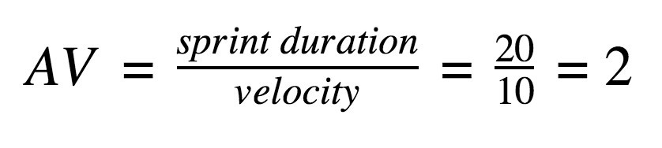
Burndown Chart:
A burn down chart is a graphical representation of work left to do versus time. It is often used in agile software development methodologies such as Scrum. However, burn down charts can be applied to any project containing measurable progress over time.
https://www.visual-paradigm.com/scrum/scrum-burndown-chart/ https://www.atlassian.com/agile/tutorials/burndown-charts
Reference: https://www.atlassian.com/agile/project-management
https://www.atlassian.com/agile/tutorials/how-to-do-scrum-with-jira-software https://www.atlassian.com/agile/tutorials/epics https://www.atlassian.com/agile/tutorials/sprints
https://www.atlassian.com/agile/project-management/estimation https://www.atlassian.com/agile/tutorials/burndown-charts

